Installing custom firmware …. A guide

Download the firmware, I’ve sent a link to a zip file. When you download it windows tries to be clever and if you view the file you’ve downloaded you’ll get a window like this,

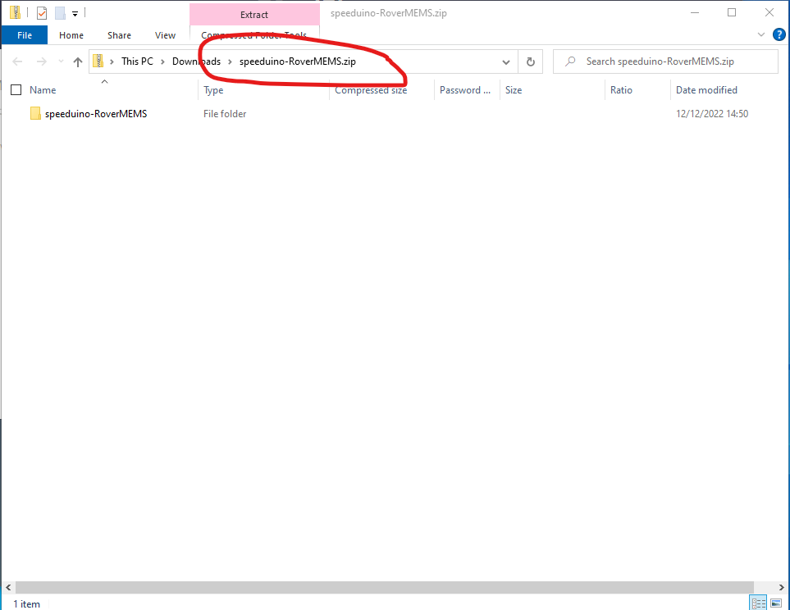

The problem is windows has been clever and realises it knows how to look inside the zip file. The software we’re using doesn’t know how to do this. We therefore need to extract the contents of the zip file into a normal directory so the software we’ll use can access it.

To do this click on the word before the .zip file. In my case that’s “Downloads”. Then you’ll see lots of files and one will be speeduino-RoverMEMS.zip. Right click on this file and select the option “Extract All”. A new window will appear like this,

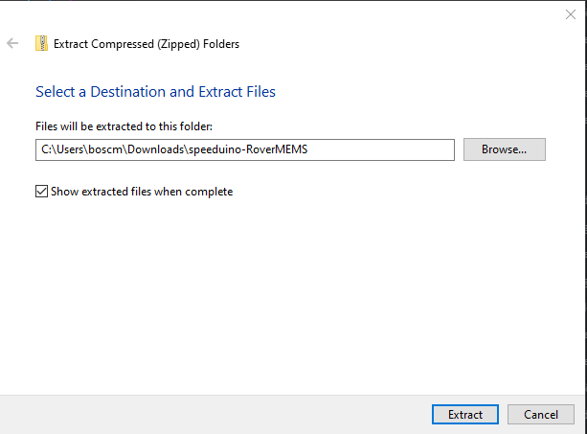

Add to the end of the filename todays date, so in my example it would look like speeduino-RoverMEMS20221213 (I always do the date in reverse order as it makes the computer sort files on date when listing the filenames)

Click the extract button. A minute or two later and you’ve got a new window like this,

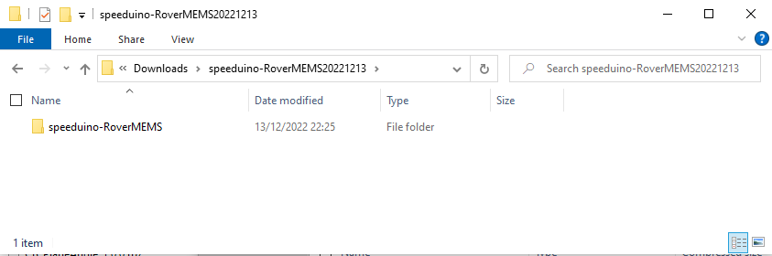

We now have the firmware we want to install on our computer.

Next we need to install and setup the compiler to burn the firmware onto the Arduino. Follow the guide located here [Speeduino Firmware setup | Speeduino Manual](https://wiki.speeduino.com/en/Installing_Firmware) starting with section “Installation – Manually Compiling using Arduino IDE” and work your way down the web page doing as instructed.

Do not forget to install the time library, the guide is a little light in instructions so here’s some more detailed ones.

Click the menu “tools” and select “manage libraries”

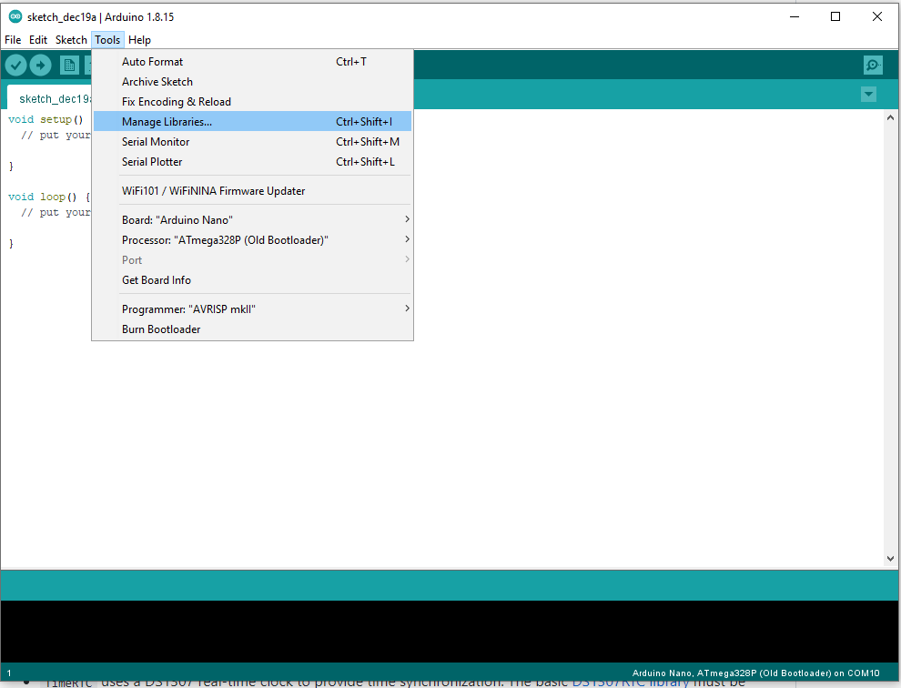

It may take a while (perhaps 30s) to display the next screen as it has to check the library index is up to date. If it is not up to date it will then download the latest index which can take a minute or two.

Once the screen is displayed, enter the words “timekeeping functionality” in the box to the right of the type and topic boxes highlighted red below and wait. After a number of seconds it will display one entry as shown below. Click “Install” (Green circle) and wait for it to complete. A blue bar will move across the screen to show progress. 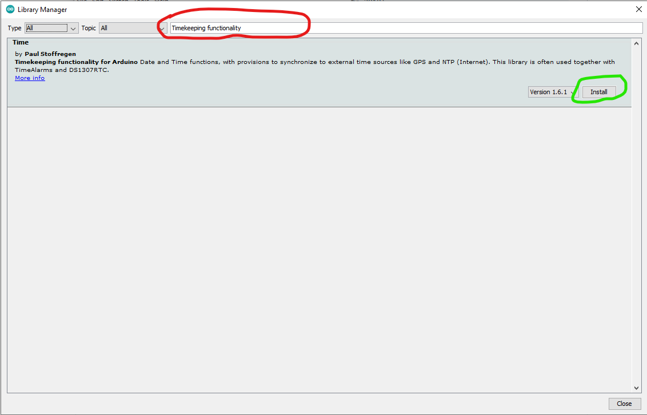

When its completed the entry for time should change to now say installed,

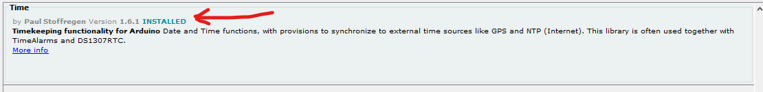

Click the close button and this task is done. Now go back to the web guide here [Speeduino Firmware setup | Speeduino Manual](https://wiki.speeduino.com/en/Installing_Firmware)

Ignore the section “Downloading the firmware” and skip to “Compiling the firmware”.

In the section “Compiling the firmware” navigate to the folder you’ve created with the date in it, then go to speeduino-RoverMEMS\speeduino and then select speeduino.ino before clicking open.

Stop when you get to the section “Older Firmware Releases”.

You should now have the firmware uploaded onto your Arduino Mega.

To use the software we need to ensure Tunerstudio knows it’s the development version of the software. This will then give the decoder option.

Keep the USB cable plugged in and exit (close) the compiler. We need to ensure the compiler is closed as its used the connection to speeduino and we now want to make use of it.

Open tunerstudio. Follow the normal instructions (link following this paragraph) for connecting to a new speeduino. The “Speeduino source directory” referenced in the instructions is within the one that you created earlier. It will be named something like ….\speeduino-RoverMEMS20221213\reference. You’ll have to figure out what the 4 dots actually are as I don’t know where you saved the file, potentially in your downloads folder.

Guide -> [Setting up TunerStudio | Speeduino Manual](https://wiki.speeduino.com/en/Connecting_to_TunerStudio)